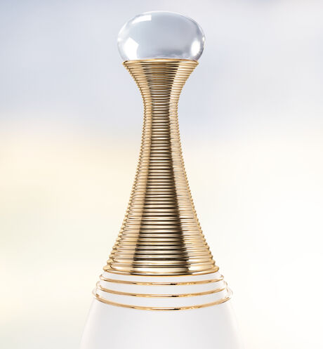

J'ADORE PARFUM D'EAU

**Alcohol-free eau de parfum - floral notes**

PKR 4,000



IN STOCK

Product Details:

The new fragrance, a concentration of water and flowers: J'adore Parfum d'eau reinvents the promise of pleasure that J'adore has upheld since 1999.

The pleasure of a reinvented J'adore bouquet with a strong natural focus: Neroli from Vallauris injects its full freshness into J'adore Parfum d'eau, while sunny notes of jasmine sambac meld with velvety notes of Chinese magnolia. A genuine ode to the white flowers of J'adore in a fresh and spontaneous interpretation.